caXchange Hub

caXchange – ScenPro, Inc.
Ekagra Software Tech.

Technical Architecture Guide
DOCUMENT CHANGE HISTORY
Version Number | Date | Contributor | Description
1.0 | 2/19/2007 | M. Medirratta  C. Griffin  W. Ver Hoef | New Document
1.1 | 1/11/2008 | Michael Holck | Updated to new template and removed non hub content
1.1 | 1/30/2008 | Amit Srivastava | Updated caXchange Hub Content
1.1 | 02/07/2008 | Amit Srivastava | Update sequence diagrams
1.1 | 02/15/2008 | Amit Srivastava | Updated formatting
1.1 | 02/19/2008 | Amit Srivastava | Updated Requirements
1.1 | 02/21/2008 | Amit Srivastava | Updated after Satish’s review
1.5 | 11/13/2008 | Harsh Marwaha | Changes for version 1.5.

Updated November 14, 2008

TABLE OF CONTENTS
1 Introduction 3
1.1 Chapter Organization and Content 3
1.2 Overview of the Guide 3
1.3 Organization of the Guide 3
1.4 Intended Audience for the Guide 4
1.5 Scope of the Guide 4
1.6 Document Text Conventions 4
1.7 Related documents 5
2 Overview of the Software 6
2.1 Chapter Organization and Content 6
2.2 Software Overview 6
2.2.1 Project Background 6
2.2.2 System Overview 6
2.2.3 Features of the caXchange Hub 7
2.3 System Requirements 7
3 caXchange Installation 9
3.1 Installation scripts 9
3.2 installation verification 9
4 caXchange Requirements 10
4.1 Chapter Organization and Content 10
4.2 Summary of caXchange Requirements 10
5 caXchange Architecture 12
5.1 Chapter Organization and Content 12
5.2 System Architecture Overview 12
5.3 Architectural Design 13
6 caXchange Design 14
6.1 Chapter Organization and Content 14
6.2 caXchange 14
6.2.1 Use Case 14
6.2.2 Logical Design 17
6.2.2.1 caXchange Inbound Grid Service 17
6.2.2.2 caXchangeResponse Listener 17
6.2.2.3 caXchange Service Assembly 18
6.2.2.4 Authentication/Authorization 21
6.2.2.5 Audit Service 22
6.2.2.6 Configuration Items 22
6.2.3 Sequence Diagrams 23
6.2.3.1 Successful Flow Sequence Diagram 23
6.2.3.2 Rollback Flow Sequence Diagram 24
6.2.4 Deployment Diagrams 26
6.3 Technology Stack 26
7 Grid Services 28
7.1 Chapter Organization and Content 28
7.2 caXchange INBOUND grid-Service 28
Technical Manuals/Articles 29
caBIG Material 29
caCORE Material 29
List of Figures
Figure 1 caXchange 1.0 High Level Data Flow 12
Figure 2 caXchange 1.0 Component Diagram 13
Figure 3 caXchange use cases 15
Figure 4 caXchange Administration use cases 16
Figure 5 caXchange ResponseListener Class Model 18
Figure 6 caXchange Detailed Design and Workflow 19
Figure 7 caXchange Successful Flow Sequence Diagram 23
Figure 8 caXchange: Rollback Sequence Diagram 25
Figure 9 - caXchange Deployment Diagram 26

List of Tables
Table 1 - Main Contents of the caXchange Technical Architecture Guide 3
Table 2 - Document Conventions 4
Table 3 - Key Roles in the caXchange Project 6
Table 4 - High Level Summary of Requirements 7
Table 5 - Summary of Detailed Requirements 10
Table 6 caXchange Grid Service Operations 17
Table 7 caXchange Service Assembly Components 20

Introduction
The caXchange Hub is the enterprise service hub for exchanging clinical trial information between applications and systems. The caXchange Hub (originally Lab Information Hub) is now a more generic platform for exchanging many types of clinical trial data and messages using service invocations and data exchange and is leveraged in the CCTS project.
This Technical Architecture Guide provides the software architecture and high level design for the caXchange Hub. This document is meant to be a recommendation and guideline to the development team to develop a detailed design for the system. It emphasizes the architecturally significant parts of the design model.

Chapter Organization and Content
The purpose of this chapter is to provide a high level overview of the caXchange hub solution, its components, and the overall content of this guide.
Topics in this chapter include:
- Overview of the Guide
- Organization of the Guide
- Scope of the Guide
- Document Text Conventions

Overview of the Guide
This guide introduces the technical and architectural aspects of the caXchange Hub Version 1.0. It provides an overview of the architecture, describes the components and their use cases, identifies the technology stack, and provides some technical reference.

Organization of the Guide
This table provides a summary of the focus of each chapter.
Table 1 - Main Contents of the caXchange Technical Architecture Guide
Chapter in caXchange Technical Architecture Guide | Chapter Contents
Chapter 1 | Introduction
Chapter 2 | Overview of the Software
Chapter 3 | caXchange Installation
Chapter 4 | CCTS bundle 1.1 now comes with integration smoke tests that can be used to verify caXchange installation. Integration smoke test scripts can be used to send test messages to caXchange. These messages verify the security infrastructure, payload validation and caXchange routing. A separate document, the CCTS Integration Smoke Test-User Guide, outlines the steps for using the integration smoke tests. Please refer to that document for details. The latest version of this document can be found in
Chapter 5 | caXchange Architecture
Chapter 6 | Grid Services
Appendix A | References
Appendix B | Glossary
Index | Index

Intended Audience for the Guide
The intended audience for this document includes developers and architects interested in obtaining an overview of the architecture and high level design for the caXchange Hub.

Scope of the Guide
The scope of this document is limited to the requirements as identified in caXchange solution version 1.0. For additional project and requirement-specific information, please refer to the following documents:
- caXchange Software Requirements Specification (SRS)
- caXchange Use Case Specification and Realization Document
The latest versions of these documents can be found in:
https://gforge.nci.nih.gov/plugins/scmcvs/cvsweb.php/caxchange/Deliverables/?cvsroot=caxchange

Document Text Conventions
The following table shows various typefaces to differentiate between regular text and menu commands, keyboard keys, and text that you type. This illustrates how conventions are represented in this guide.
Table 2 - Document Conventions
Convention | Description | Example
Bold & Capitalized Command  Capitalized command > Capitalized command | Indicates a Menu command  Indicates Sequential Menu commands | Admin > Refresh
text in small caps | Keyboard key that you press | Press enter
text in small caps + text in small caps | Keyboard keys that you press simultaneously | Press shift + ctrl and then release both.
Special typestyle | Used for filenames, directory names, commands, file listings, source code examples and anything that would appear in a Java program, such as methods, variables, and classes. | URL_definition ::= url_string
Boldface type | Options that you select in dialog boxes or drop-down menus. Buttons or icons that you click. | In the Open dialog box, select the file and click the Open button.
Italics | Used to reference other documents, sections, figures, and tables. | caCORE Software Development Kit 1.0 Programmer’s Guide
Italic boldface type | Text that you type | In the New Subset text box, enter Proprietary Proteins.
Note: | Highlights a concept of particular interest | Note: This concept is used throughout the installation manual.
Warning! | Highlights information of which you should be particularly aware. | Warning! Deleting an object will permanently delete it from the database.
{} | Curly brackets are used for replaceable items. | Replace {root directory} with its proper value such as c:\cabio

Related documents
For additional project information, please refer to the following documents:
- caXchange Software Requirements Specification (SRS)
- caXchange Use Case Specification and Realization Document
- caXchange Design Document
- caXchange Installation Guide
- caXchange Administration Guide
The latest versions of these documents can be found in:
https://gforge.nci.nih.gov/plugins/scmcvs/cvsweb.php/caxchange/Deliverables/?cvsroot=caxchange

Overview of the Software

Chapter Organization and Content
Topics in this chapter include:
- Project Background
- System Overview
- Features of the caXchange Hub
- System Requirements

Software Overview

Project Background
The CCTS suite of applications needs to be able to exchange information among themselves in an audited and controlled manner. The caXchange hub provides this capability by using standard service hub protocols and messaging formats to receive, route, log, and send messages and data between applications. It can also be used to send and receive clinical trial lab information as was done in the original lab information hub effort.
This project focuses on the development of an open-source, caBIG™ compatible solution to support the exchange of data collected during a clinical trial. The resulting solution is intended to be stand-alone and caBIG Silver-level compatible.

System Overview
Goal of this project is to build a hub system that can route messages based on standard format and can be extended to use other messaging format needed by the cancer centers. As the caBIG program is the primary sponsor, all work performed for this project must be done in compliance with the caBIG principles of open source, open development, open access, and federation. Software that is used and/or developed in the context of this project must be caBIG™ compatible at the silver level (https://cabig.nci.nih.gov/guidelines_documentation/caBIGCompatGuideRev2_final.pdf) and be made available to the community through resources provided by the General Contractor.
The key roles in the project are defined in the following table.
Table 3 - Key Roles in the caXchange Project
Role | Name | Comments
Project Sponsor | caBIG
Reviewer | caBIG Architecture Workspace | Will review and provide guidance of architecture artifacts
Reviewer | caBIG Lab SIG | Will provide requirements feedback
User | NCICB | Responsible for hosting the caXchange
Developer | Scenpro, Ekagra Software Technologies | Joint development team

Features of the caXchange Hub
Key features of the caXchange solution include the following:
- Has a service oriented flexible and extensible architecture
- Built upon open source ESB technology – Apache ServiceMix
- Has reusable services built to the Java Business Integration (JBI) specification that can be deployed to any JBI container.
- Supports message routing and customized workflows.
- Externalized configuration can be used to configure caXchange to add /remove target services.
- Can be configured for new service types. This is in addition to the six service types pre-configured for CCTS.
- Payload validation using schemas defined in Global Model Exchange.
- Provides an installation script to install all caXchange components.
- Integration smoke tests to verify caXchange installation.
- Supports caGrid user authentication and authorization.
- Provides a Log Locator Tool to view the message exchange status.

System Requirements
The following table provides a very high-level summary of the requirements of the caXchange system:
Table 4 - High Level Summary of Requirements
Requirement ID | Requirement Description
1.0 | The caXchange Hub must provide the ability to receive, transform, and route CT Laboratory Observation Periodic Report in HL7v3 format to various external systems.
2.0 | The caXchange Hub must provide the ability to monitor the caXchange activities and perform administrative functions on the caXchange.
3.0 | The system must provide Architectural and User documentation for the technical components developed by the caXchange technical team.
4.0 | The caXchange Hub will allow communication of non-grid applications on caXchange ESB to Grid Services or Grid Clients
5.0 | The caXchange Hub must be enhanced to automate custom workflow by routing rules in the database to provide routing to multiple services and support itinerary based routing.

A more in-depth summary of the system requirements is presented in Chapter 4 caXchange Requirements. Alternatively, a more detailed understanding of the requirements can be found in the requirements document: caXchange Project Software Requirements Specification. The URL to this document is:
https://gforge.nci.nih.gov/plugins/scmcvs/cvsweb.php/caxchange/Deliverables/Updated%20Requirements%20and%20Specifications%20Document%20(Task%203.2.3).doc?cvsroot=caxchange

caXchange Installation

Installation scripts
A separate document, the caXchange Version 1.5 Installation Guide, outlines the steps for installing and configuring the various components that comprise the caXchange version 1.5 solution. caXchange installation has been streamlined using ant scripts. Ant scripts are provided to install and configure various caXchange components. Please refer to that document for details. The latest version of this document can be found in
https://gforge.nci.nih.gov/plugins/scmcvs/cvsweb.php/caxchange/Documentation/installation/caXchange%20Installation%20Guide.doc?cvsroot=caxchange

installation verification
CCTS bundle 1.1 now comes with integration smoke tests that can be used to verify caXchange installation. Integration smoke test scripts can be used to send test messages to caXchange. These messages verify the security infrastructure, payload validation and caXchange routing. A separate document, the CCTS Integration Smoke Test-User Guide, outlines the steps for using the integration smoke tests. Please refer to that document for details. The latest version of this document can be found in
http://gforge.nci.nih.gov/plugins/scmcvs/cvsweb.php/caxchange/Documentation/Testing/CCTS%20Integration%20Smoke%20Test-User%20Guide.doc?cvsroot=caxchange

caXchange Requirements

Chapter Organization and Content
This chapter includes:
- Summary of caXchange Requirements on this page

Summary of caXchange Requirements
This section summarizes the requirements documented in the caXchange Project Software Requirements Specification document
https://gforge.nci.nih.gov/plugins/scmcvs/cvsweb.php/caxchange/Deliverables/Updated%20Requirements%20and%20Specifications%20Document%20(Task%203.2.3).doc?cvsroot=caxchange
Table 5 - Summary of Detailed Requirements
Requirement ID | Requirement Description
1.0 | The system must accept the grid credential of the authenticated user from the grid client or grid service.
1.1 | The system must perform a check to ensure that the sender of each message is authorized to perform a defined workflow on the caXchange.
1.2 | The system must send an Acknowledgement Response to the sender indicating the message was successfully received. A successful audit message must be logged.
1.3 | If an error occurred or user authorization failed, then an Error Response must be returned to the sender indicating the reason why the request failed. In case of failure, an error audit message must be logged.
1.4 | After a message is received, the system must normalize and route it to the appropriate service on the caXchange. The routing will be done based on metadata in the received message.
1.5 | The system must accept the grid credential of the authenticated user from the grid client or grid service.
1.6 | The system must provide the ability to route an incoming message from the Cancer Center Hub client to the CTODS persistence Service.
1.7 | The system will provide the ability to guarantee message delivery to services on the caXchange even in the event of a server shut down.
1.8 | The system must support the concept of a normalized message. A normalized message meaning a common message interface or construct that the caXchange can route to services deployed on the caXchange.
1.9 | The system must provide the ability to view the audit/log data repository for audits and logs in a specified period of time
1.10 | The system will ensure that each Cancer Center is able to view their respective audits/logs.
1.11 | The system will provide a service (Audit/Log Service) on the caXchange that audits messages exchange occurring inside the caXchange
1.12 | The Audit/Log Service will persist the audit/log data received in the message in a common audit /log data store.
1.13 | The system must audit requests sent to any service on the ESB without the service actually pushing messages to the audit service.
1.14 | The system must ensure that the retrieval of the credential information from the message is possible
2.1 | The caXchange must provide the ability to install new services on the caXchange without disrupting processing of existing services and messages
2.2 | The caXchange must provide the caXchange Administrator the ability to shutdown the caXchange
2.3 | The caXchange must provide the Administrator the ability to view and retrieve audit logs
3.1 | Technical Architecture Guide
3.2 | Installation Guide
3.3 | Administrative Guide
3.4 | CCHC SOP – An SOP must be written that specifies security configuration and procedures for CCHC.
4.1 | The system will develop a way for non-Grid Services to be advertised on the Grid’s Index Service so that they can be discovered and used by Grid clients and Grid Services
4.2 | The system must provide an XML transformation framework that transforms XML to HL7 v3 messages
4.3 | The system will register HL7 v3 data type in the caDSR
5.1 | A message exchange framework based on the BRIDG model (similar to an HL7 XML ITS based on the RIM) to implement the wire-format for CCTS messages must be developed. The message structures will be developed and managed in conjunction with the CCTS Analyst team.
5.2 | The system should be able to route BRIDG based XML messages
5.3 | The system should be able to validate payloads making sure that they match the service being invoked before invoking the target services.
5.4 | The system is configurable so that new service types can be defined and additional target services can be configured.
Please refer to the requirements document identified above for a more detailed understanding of these requirements.

caXchange Architecture

Chapter Organization and Content
Topics in this chapter include:
- System Architecture Overview
- Architectural Design

System Architecture Overview
- caXchange provides the ability to route request from multiple originating systems to various destinations. The destinations to which request will be routed may accept data in various formats.
- Figure 1 shows a high-level view of the flow of data that will take place in caXchange1.0. As shown, caXchange will receive requests from different sources and will route them to various targets based on the type request.
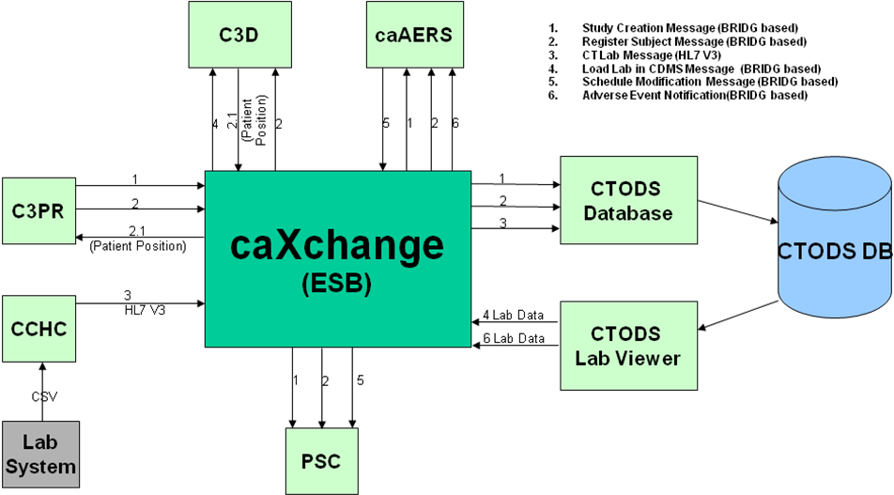
Figure 1 caXchange 1.0 High Level Data Flow

Architectural Design
caXchange uses Apache ServiceMix open source enterprise service bus (ESB). Services and components have been written and deployed on the ESB to provide routing and transformation services.
The following diagram depicts the high level components in caXchange:
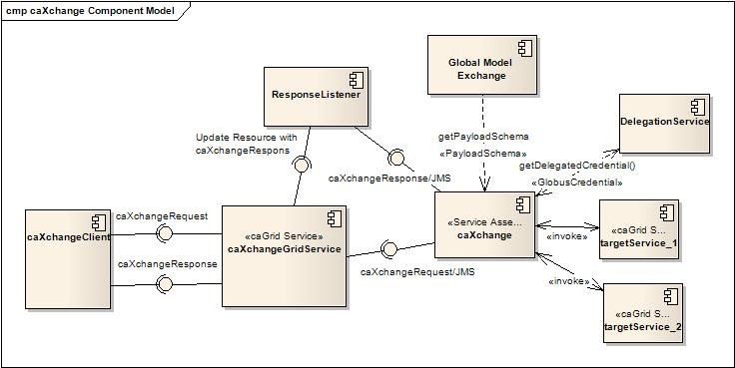

Figure 2 caXchange 1.0 Component Diagram
- A caXchange client sends a caXchangeRequest message to caXchangeGridService.
- caXchangeGridService is a caGrid service which acts as a proxy for the caXchange service assembly deployed on Servicemix JBI(Java Business Integration) Container.
- caXchangeGridService creates a WS-Resourceframework Resource associated with the caXchangeRequest. This caXchangeRequest is then forwarded to the caXchange service assembly for processing. This is done by pushing caXchangeRequest message to the JMS inbound component of caXchange service assembly.
- caXchange service assembly then validates the payload against the schema for the caXchange service type. The schema is retrieved from Global Model Exchange.
- caXchange service assembly then invokes the DelegationService for the authorization credentials before routing the request message based on the message type. Please refer to the caXchange detailed design diagram for routing details.Outbound components then invoke the target services.
- Responses from the target services are then aggregated into a caXchangeResponse message

caXchange Design

Chapter Organization and Content
Topics in this chapter include:
- caXchange
- Technology Stack

caXchange
The caXchange is defined as the software component that is primarily responsible for receiving input from various external systems, routing the input to various services that are hosted on the grid, and eventually routing the output of those services to external systems. The caXchange is based on Apache ServiceMix which is an Enterprise Service Bus (ESB) built to the Java Business Integration (JBI) specification.

Use Case
The following diagrams show the use cases and actors. For more details on the use cases, please refer to the caXchange Enterprise Architect Use Case Model.
(https://gforge.nci.nih.gov/plugins/scmcvs/cvsweb.php/caxchange/Documentation/Design/caXchange%20Design.eap?cvsroot=caxchange).

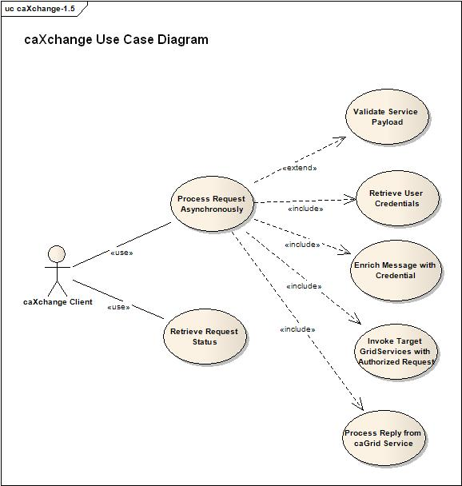
Figure 3 caXchange use cases

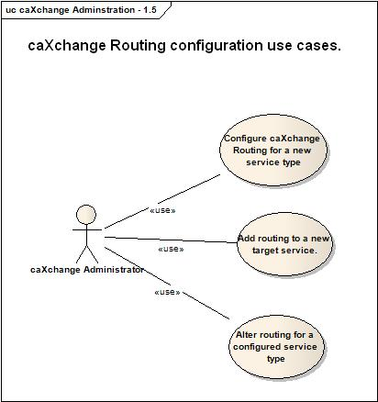
Figure 4 caXchange Administration use cases

Logical Design

caXchange Inbound Grid Service
caXchange grid service acts as a proxy for caXchange. It pushes the incoming requests to inbound JMS queue from where caXchange picks it up for further processing. To keep track of a request it creates a WS-Resource framework resource. The grid service returns an EndPointReference to the client. The client uses this end point reference to invoke the getResponse operation. The grid service also creates a response listener, which listens for caXchangeResponse and updates the resource. Please see the caXchange interface specification document for details of the operations it exposes.

Operations
Table 6 caXchange Grid Service Operations
Method | Notes | Parameters | Return
ProcessRequestAsynchronously | Process a caXchangeRequest | CaXchangeRequest | CaXchangeContextReference
getResponse | Gets the caXchangeResponse if it is ready, otherwise throws an Exception | None | caXchangeResponse

caXchangeResponse Listener
The caXchangeResponse listener lives with the caXchange Grid service. It listens for the response on the JMS queue associated with the response outbound component of the caXchange service assembly. Once a response is received from the queue, the resource associated with the corresponding request is updated. The client can then use the getResponse method to get the caXchangeResponse.
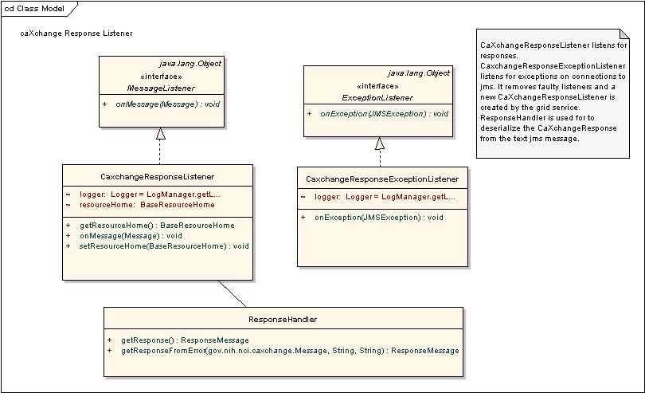
Figure 5 caXchange ResponseListener Class Model

caXchange Service Assembly
A Service Assembly is a single standard document describing the routing, artifacts, and services that make up an SOA application. caXchange service assembly is deployed on the Servicemix JBI container. The caXchange design diagram below gives the detailed design of the caXchange service assembly.
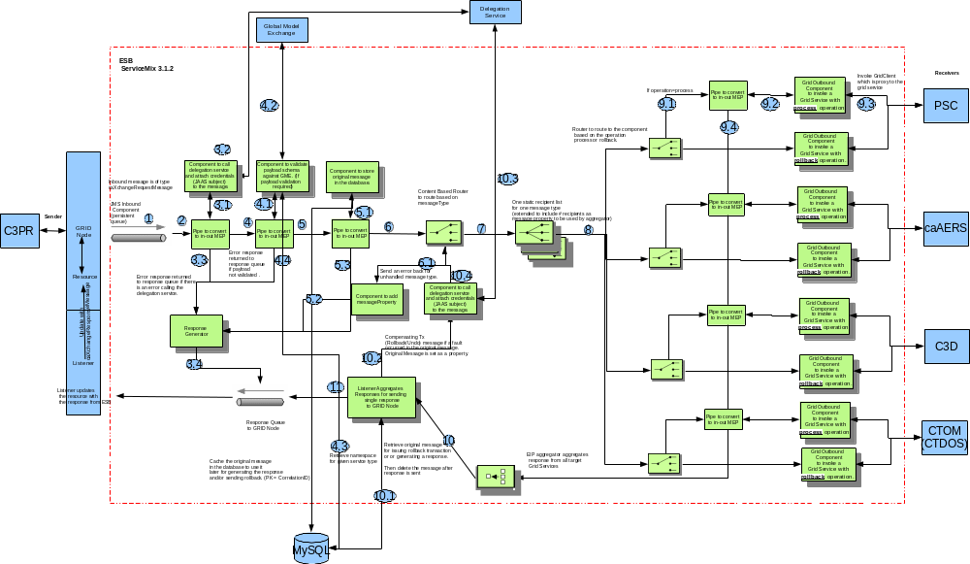
Figure 6 caXchange Detailed Design and Workflow

The following table describes caXchange service assembly components. Numbers in the component column refer to the number in the above caXchange design diagram given to an exchange going into that component.
Table 7 caXchange Service Assembly Components
Component | Type | Purpose
1. InboundComponent | JMS | Receive inbound caXchangeRequest messages.
3.1 Invoke Delegation Service | Bean/EIP (Enterprise Integration Patterns) | This includes a pipeline, which invokes a bean component that calls delegation service for authentication and attaches the credentials (JAAS subject) to the message.
4.1 Invoke Payload Validation Service | Bean/EIP | This includes a pipeline, which invokes a bean component that retrieves namespace according to service type from Global Model Exchange (GME).
3.3/4.3/5.3 Response Generator | Bean | Generates an error response.
5.Save Message | Bean/EIP | This includes two components, a pipeline, which invokes a bean component that saves the message to a database. The saved message is used to contruct a response and/or sends a rollback.
6. Content Based Router | EIP | Routes the message based on the message type to a particular static recipient list.
7. Static Recipient List | EIP Customized | Sends the message to multiple recipients for invoking target services. This is customized to add a message property for number of recipients. This is used to aggregate responses
8. Content Based Router | EIP | Routes message based on operation. If the operation is process the message is routed to a pipeline to invoke the service and get a response as an in-out message exchange. If the operation is rollback the message is send without expecting a response as an in-only message exchange.
9.1 Pipeline | EIP | Pipeline to invoke target service as an in-out message exchange.
9.2 Outbound Component | Bean | Outbound component that invokes the target Grid Service.
9.4 Aggregator | EIP Customized | Aggregator component aggregates responses from multiple target services. This is customized to work with the customized static recipient list in #6 above.
10 Aggregator Listener | Bean | Aggregated responses from the aggregator are forwarded to this component, which does two things.  - It looks at the response and the message type to verify if a rollback is required. If required a message with the rollback is sent to the content based router #5 after authentication and authorization by #3.  - It creates a caXchangeResponse and sends it to the JMS outbound binding component.
11.ResponseComponent | JMS | Outbound caXchangeResponse are pushed to this component.

Authentication/Authorization

Delegation Services
Delegation Service is a WSRF-compliant Grid service that enables users/services (delegator) to delegate their Grid credentials to other users/services. Applications use it for passing on their credentials to caXchange.
- Each caXchangeRequest comes with an End Point Reference (EPR) pointing to its credentials.
- caXchange then invokes DelegationService using the EPR
- The DelegationService return back the userCredentials (JAAS Subject) in the EPR is valid.
- Attaches the JAAS Subject to the message
- The outbound component then retrieves the JAAS Subject and uses it to invoke the target grid services.

CSM Authentication Manager
CSM is a comprehensive solution to common security objectives. It is used by the Log Locator Tool (LLT) for authentication/authorization and not directly by caXchange. The CSM AuthenticationManager is an interface that authenticates a user against a credential provider. The AuthenticationManager contains several methods, details of which can be found in caCORE3.1_Tech_Guide (chapter 9 – CSM Module). For the current scope of the caXchange implementation, the private boolean login (SenderID, Password) method from this interface is used.

CSM AuthorizationManager
CSM is used only for Log Locator Tool (LLT) and not directly by caXchange. The CSM AuthorizationManager is an interface that authorizes a user and its desired operation against an authorization schema. The AuthorizationManager contains several methods, details of which can be found in caCORE3.1_Tech_Guide (chapter 9 – CSM Module). For the current scope of the caXchange implementation, the method used is private boolean checkPermission(senderID, serviceId, desiredOperation) from this interface.

Audit Service
The Audit Service is implemented following JBI specifications on the caXchange. This service will perform the following:
- Receives notification on each MessageExchange.
- Check whether it needs to audit for that message.
- Extract the audit information and sends it to Common Logging Module (CLM) for auditing.
- CLM stores it in database.
- The CLM API takes these messages from the database and displays on the Log Locator Tool
- Users on LLT can see messages only for the organization for which they are authorized. Also the users can view messages based on the session ID which is linked to the file name (along with a date/time stamp) sent in by the external clients.

Configuration Items
The database location, target grid-services url’s and JMS Queue locations are configurable items and are stored as properties in the conf/caxchange.properties file. Additionally caXchange has externalized its routing configuration. This enables caXchange administrators to configure caXchange for new service types, add routing to new target services, remove routing to target services, configure payload validation among other things. caXchange Administrators Guide provides details on configuring caXchange. The latest copy of this document is located here:
http://gforge.nci.nih.gov/plugins/scmcvs/cvsweb.php/caxchange/Documentation/admin/?cvsroot=caxchange

Sequence Diagrams

Successful Flow Sequence Diagram
Sequence for a successful flow through caXchange is depicted below. Detailed flow through the caXchange service assembly is depicted in the caXchange design diagram.
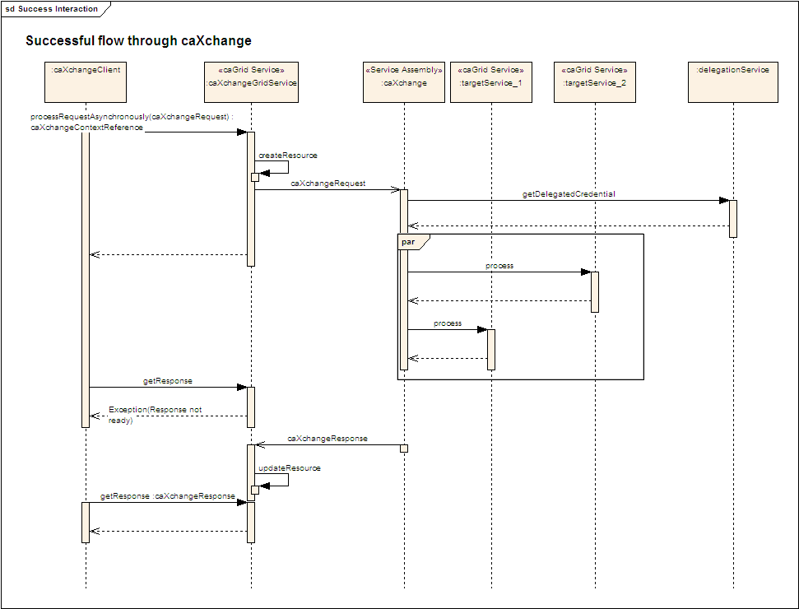
Figure 7 caXchange Successful Flow Sequence Diagram
- caXchangeGridService receives a request, create a Resource associated with the request.
- The gridService sends back an EPR associated with the resource to the client which it uses to check the status of the request.
- caXchangeGridService then puts the request into the JMS queue from where it is picked up by the caXchange Service Assembly.
- caXchange Service Assembly then validates the request payload against the schema registered for the service payload namespace. caXchange caches the schemas from Global Model Exchange for payload validation.
- caXchange Service Assembly invokes the Delegation Service for the credentials of the request.
- Request is forwarded to all the target endpoints.
- If none of the target endpoints report any problem then responses are aggregated and sent back to the client.

Rollback Flow Sequence Diagram
Sequence for a rollback interaction with caXchange is depicted below. Detailed interaction within caXchange service assembly is depicted in the caXchange design diagram.
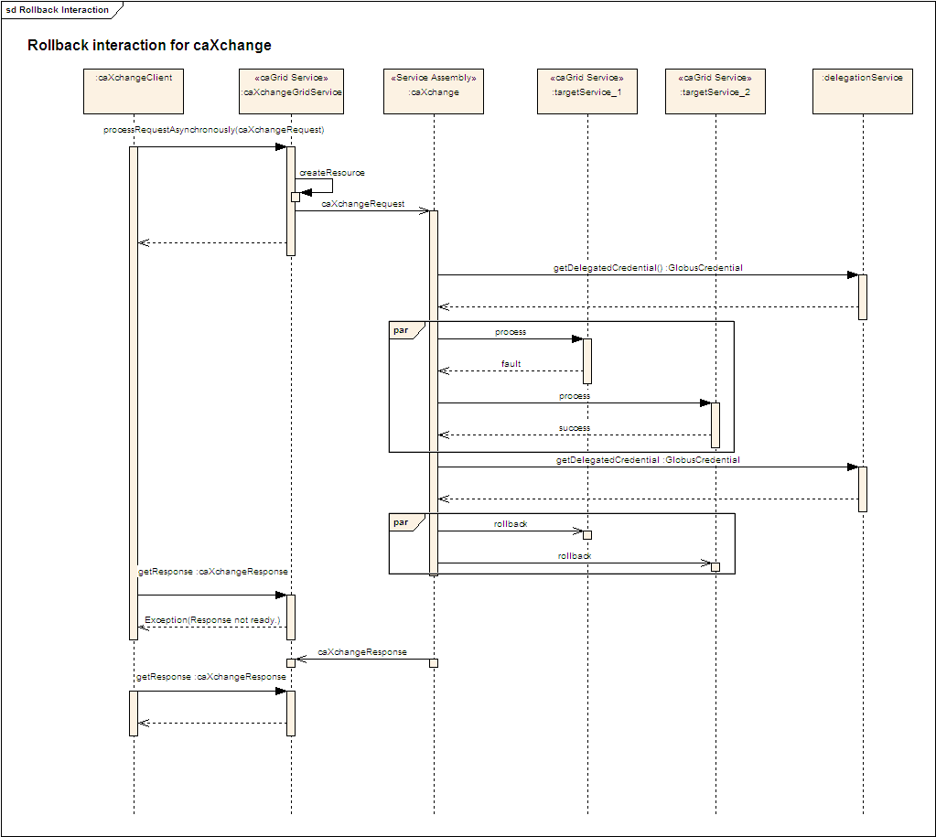
Figure 8 caXchange: Rollback Sequence Diagram
- caXchangeGridService receives a request, create a Resource associated with the request.
- The gridService sends back an EPR associated with the resource to the client which it uses to check the status of the request.
- caXchangeGridService then puts the request into the JMS queue from where it is picked up by the caXchange Service Assembly.
- caXchange Service Assembly invokes the Delegation Service for the credentials of the request.
- Request is forwarded to all the target endpoints.
- If any target endpoints reports any problem then a rollback is sent to all the target-endpoints.
- All the responses are aggregated and sent back to the client along with a FAILURE status.

Deployment Diagrams
The following depicts the deployment diagram for caXchange components.
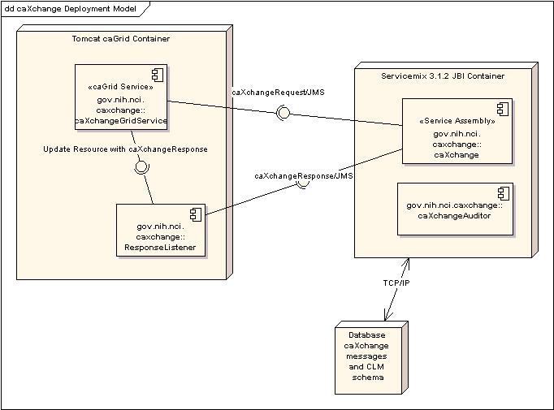
Figure 9 - caXchange Deployment Diagram

Technology Stack
The following technologies are used in the caXchange solution or in the development of the solution:
- JDK 1.5.0
- Apache ServiceMix 3.1.2
- Apache Ant 1.6.5
- MySQL 4.1.22
- Apache Tomcat 5.0.28
- Enterprise Architect 7.1+
- caGrid 1.2
Extensive instructions on the installation and configuring of the core software components used in the caXchange solution are covered in the caXchange Installation Guide, located along with all the other caXchange project deliverables at:
https://gforge.nci.nih.gov/plugins/scmcvs/cvsweb.php/caxchange/Deliverables/?cvsroot=caxchange.

Grid Services

Chapter Organization and Content
Topics covered in this chapter include:
- caXchange INBOUND grid-Service

caXchange INBOUND grid-Service
caXchange grid service acts as a proxy to service-assembly. Clients can send caXchangeRequest via HTTPS to grid service which pushes them into a JMS queue. Service-assembly then picks it up from there. The interface for the caXchange Grid Service is detailed in the caXchange interface specification document. This latest version of this document can be obtained here:
http://gforge.nci.nih.gov/plugins/scmcvs/cvsweb.php/caxchange/Documentation/Interface/caXchange_Interface_Specification.doc?cvsroot=caxchange
The caXchange schema provides the interface details for the caXchange inbound service. The latest version of the caXchange schema can be found here:
http://gforge.nci.nih.gov/plugins/scmcvs/cvsweb.php/caxchange/Documentation/Interface/schema.zip?cvsroot=caxchange
Appendix A References

Technical Manuals/Articles
- National Cancer Institute. “caCORE SDK 3.2 Programmers Guide”: http://ncicb.nci.nih.gov/infrastructure/cacoresdk
- Java Bean Specification: http://java.sun.com/products/javabeans/docs/spec.html
- Foundations of Object-Relational Mapping: http://www.chimu.com/publications/objectRelational/
- Object-Relational Mapping articles and products: http://www.service-architecture.com/object-relational-mapping/
- Hibernate Reference Documentation: http://www.hibernate.org/hib_docs/reference/en/html/
- Basic O/R Mapping: http://www.hibernate.org/hib_docs/reference/en/html/mapping.html
- Java Programming: http://java.sun.com/learning/new2java/index.html
- Javadoc tool: http://java.sun.com/j2se/javadoc/
- Junit: http://junit.sourceforge.net/
- Extensible Markup Language: http://www.w3.org/TR/REC-xml/
- XML Metadata Interchange: http://www.omg.org/technology/documents/formal/xmi.htm

caBIG Material
- caBIG: http://cabig.nci.nih.gov/
- caBIG Compatibility Guidelines: http://cabig.nci.nih.gov/guidelines_documentation

caCORE Material
- caCORE: http://ncicb.nci.nih.gov/core
- caBIO: http://ncicb.nci.nih.gov/core/caBIO
- caDSR: http://ncicb.nci.nih.gov/core/caDSR
- EVS: http://ncicb.nci.nih.gov/core/EVS
- CSM: http://ncicb.nci.nih.gov/core/CSM
Appendix B Glossary
Term | Definition
{jboss-home} | The base directory where Jboss is installed on the server
API | Application Programming Interface
caBIG | cancer Biomedical Informatics Grid
caBIO | Cancer Bioinformatics Infrastructure Objects
caCORE | cancer Common Ontologic Representation Environment
cardinality | Cardinality describes the minimum and maximum number of associated objects within a set
CDISC | Clinical Data Interchange Standards Consortium
CSM | Common Security Module
CTMS | Clinical Trial Management Systems
CVS | Concurrent Versions System
DAO | Data Access Objects
DAS | Distributed Annotation System
EA | Enterprise Architect
EBI | European Bioinformatics Institute
EVS | Enterprise Vocabulary Services
GULCCC | Georgetown University Lombardi Cancer Center
HIPPA | Health Insurance Portability and Accountability Act
HTTP | Hypertext Transfer Protocol
ISO | International Organization for Standardization
JAAS | Java Authentication and Authorization Service
JAR | Java Archive
Javadoc | Tool for generating API documentation in HTML format from doc comments in source code (http://java.sun.com/j2se/javadoc/)
JBI | Java Business Integration
JDBC | Java Database Connectivity
JET | Java Emitter Templates
JMI | Java Metadata Interface
JSP | JavaServer Pages
JUnit | A simple framework to write repeatable tests (http://junit.sourceforge.net/)
LDAP | Lightweight Directory Access Protocol
LLT | Log Locator Tool
LOINC | Logical Observation Identifier Names and Codes
MedDRA | Medical Dictionary for Regulatory Activities
metadata | Definitional data that provides information about or documentation of other data.
Multiplicity | Multiplicity of an association end indicates the number of objects of the class on that end may be associated with a single object of the class on the other end
NCI | National Cancer Institute
NCICB | National Cancer Institute Center for Bioinformatics
OMG | Object Management Group
ORM | Object Relational Mapping
RDBMS | Relational Database Management System
SDK | Software Development Kit
Semantic connector | A development kit to link model elements to NCICB EVS concepts.
SIG | Special Interest Group
SQL | Structured Query Language
UI | User Interface
UID | User Identification
UML | Unified Modeling Language
UMLS | Unified Medical Language System
UPT | User Provisioning Tool
URL | Uniform Resource Locators
WAR | Web Application Archive
WSDL | Web Services Description Language
XMI | XML Metadata Interchange (http://www.omg.org/technology/documents/formal/xmi.htm) - The main purpose of XMI is to enable easy interchange of metadata between modeling tools (based on the OMG-UML) and metadata repositories (OMG-MOF) in distributed heterogeneous environments
XML | Extensible Markup Language (http://www.w3.org/TR/REC-xml/) - XML is a subset of Standard Generalized Markup Language (SGML). Its goal is to enable generic SGML to be served, received, and processed on the Web in the way that is now possible with HTML. XML has been designed for ease of implementation and for interoperability with both SGML and HTML

Index

Architecture, 8
Components, 20
Data Flow, 9
Deployment Diagram, 20
Document Conventions, 2
Features, 4, 5
Grid, 1, 22, 26
hub, 4, 12
Installation, 6, 21
Logic Blaze Fuse, 5
Process Flow, 14
requirements, 2, 4, 5, 7
Security, 26
Web Services, 22, 27
WSDL, 18, 27

